MISSIONARIES CANNIBAL PROBLEM

AIM: To write a python program for Missionaries Cannibal Problem.

OBJECTIVES:
- To understand the Missionaries and Cannibals problem.
- To find a valid sequence of moves without violating the safety condition.
- To learn the basics of state-space search in Artificial Intelligence.

ALGORITHM:
- Start the program.
- Represent the initial state as 3 missionaries and 3 cannibals on the left side.
- Move people across the river according to the boat capacity.
- Ensure that missionaries are never outnumbered by cannibals on either side.
- Repeat the moves until all missionaries and cannibals reach the right side.
- Display each valid state.
- Stop the program.

SYSTEM ARCHITECTURE:
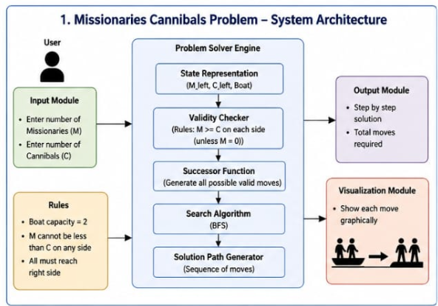

PROGRAM:
left_m = 3
left_c = 3

moves = [(0,2),(0,1),(2,0),(1,0),(1,1),
(0,2),(2,0),(0,1),(0,2),(1,0),(1,1)]

print("Left(M,C)\tRight(M,C)")

for m, c in moves:
left_m -= m
left_c -= c

right_m = 3 - left_m
right_c = 3 - left_c

if (left_m == 0 or left_m >= left_c) and (right_m == 0 or right_m >= right_c):
print((left_m, left_c), "\t", (right_m, right_c))

left_m += m
left_c += c
OUTPUT:
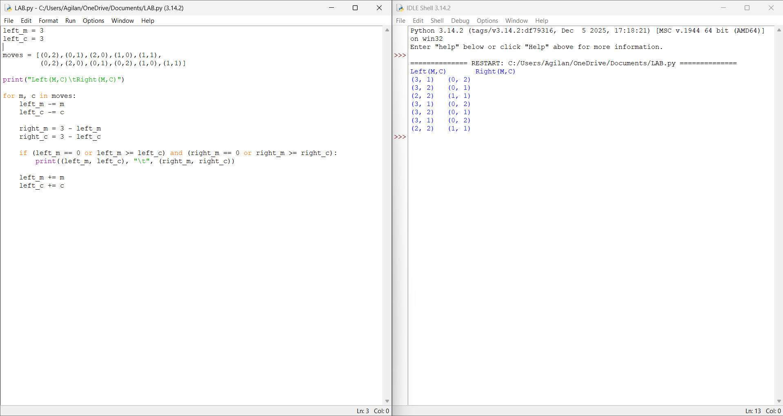
RESULT: Thus the Missionaries Cannibal Problem is implemented successfully using python language.

